CPSC 1301 COMPUTER SCIENCE 1 FALL2014
Assignment 2 – From Algorithm to Code
Recycling (Python / Turtle Graphics)
Posted on 9/7/2014
Due on Monday, September 15, 11 :59 PM EST
Total Points : 50

Work in groups of two on this assignment.

Objective: This assignment continues the work from Assignment #1. In this assignment, you’ll apply what you have learned so far about the representation of a problem solution in pseudocode and translating it into a working program in Python.

Problem statement: CSU is considering replacing the recycling bins for plastic bottles and for aluminum cans. Your program is to ask the user for the three dimensions of the recycling bin being considered and then answer the questions:
- how many plastic bottles can fit in one bin?
- how many aluminum cans fit in one bin?

PART A (30 pts): Your task will be to convert a portion of the pseudocode solution of assignment 1 as given below into Python code. Use the can/bottle dimensions from assignment 1 as named constants for this assignment.

Pseudocode
Initialize diameter of 12oz can to 2.5 inches
Initialize height of 12oz can to 4.85 inches
Initialize diameter of 16.9oz (500 ml) bottle to 2.5 inches
Initialize height of 16.9oz (500 ml) bottle to 8 inches

Prompt user and GET length of recycling bin
Prompt user and GET width of recycling bin
Prompt user and GET height of recycling bin

COMPUTE volume of can (pi * radius² * height)
COMPUTE volume of bottle (pi * radius² * height)
COMPUTE volume of recycling bin (length * width * height)

COMPUTE number of cans that can fit in the recycling bin (volumeBin / volumeCan)
COMPUTE number of bottles that can fit in the recycling bin (volumeBin / volumeBottle)
DISPLAY how many aluminum cans fit in one bin
DISPLAY how many plastic bottles can fit in one bin

PART B (20 pts): Use Turtle graphics in Python to draw a picture of something related to garbage and/or recycling.

Your programs must have the following header comment lines as the first lines in your source code file:
# TITLE: Assignment 2a – Recycling (recycling.py)
# Purpose: This program calculates the volume of a recycling bin and then
# determines how many cans and how many bottles will fit in one bin
# Author(s): < your name(s) >
# Date: <date of completion>
#===========================================================

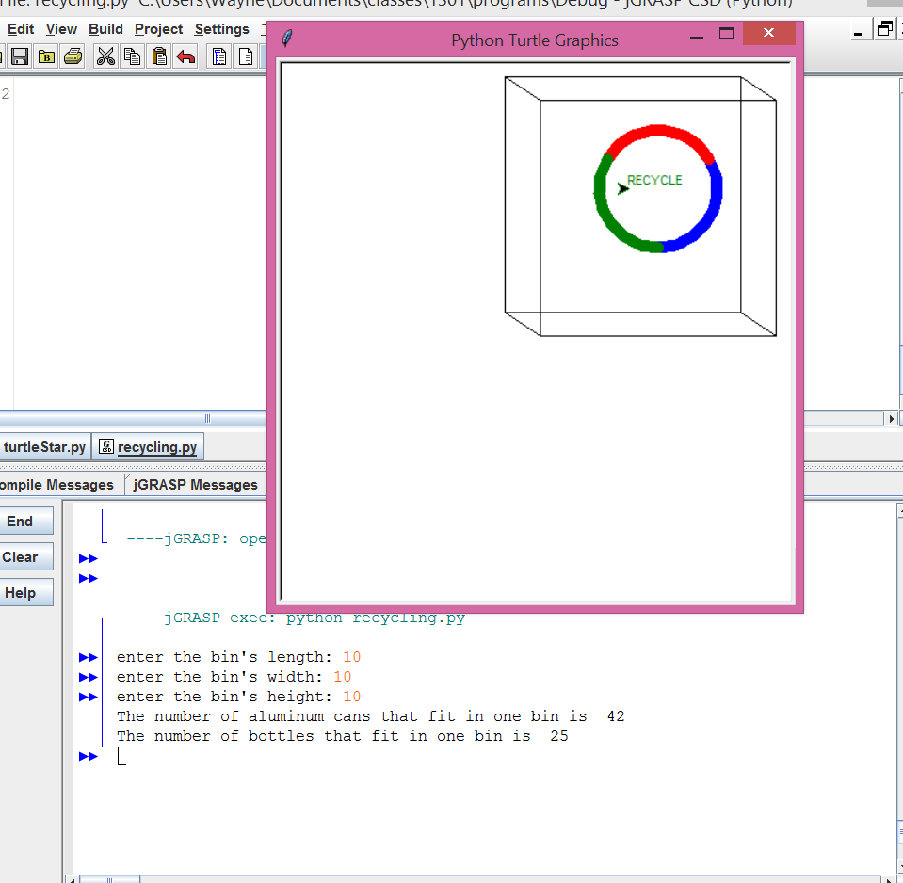
(Due before 11:59pm on Monday, September 15, 2014) Submit your .py file containing your program and your timesheet documenting your time to the CPSC 1301 Assignment 2 dropbox in CougarView.
[BOTH TEAM MEMBERS MUST SUBMIT THE SOLUTION]
Name your file <last name1>_<last name2>_Assignment2a.py>

Grades are determined using the following scale: PARTA: PART B:
- Runs correctly (no syntax / symantic errors) ..…………………:___/6 ……:___/4
- Correct output (no logic errors) ……..……………:___/6 ……:___/4
- Design of output (easy to read, picture) ……..……………:___/6 ……:___/4
- Design of logic ……..……………:___/6 ……:___/4
- Standards (variable names, indentation) ……..……………:___/3 ……:___/2
- Documentation (header, complicated parts) ……..……………:___/3 ……:___/2

